CHAPTER 7: Chemical reactions
Worksheet 7.2

Campsite chillout
Science Quest 9: pages 258–61
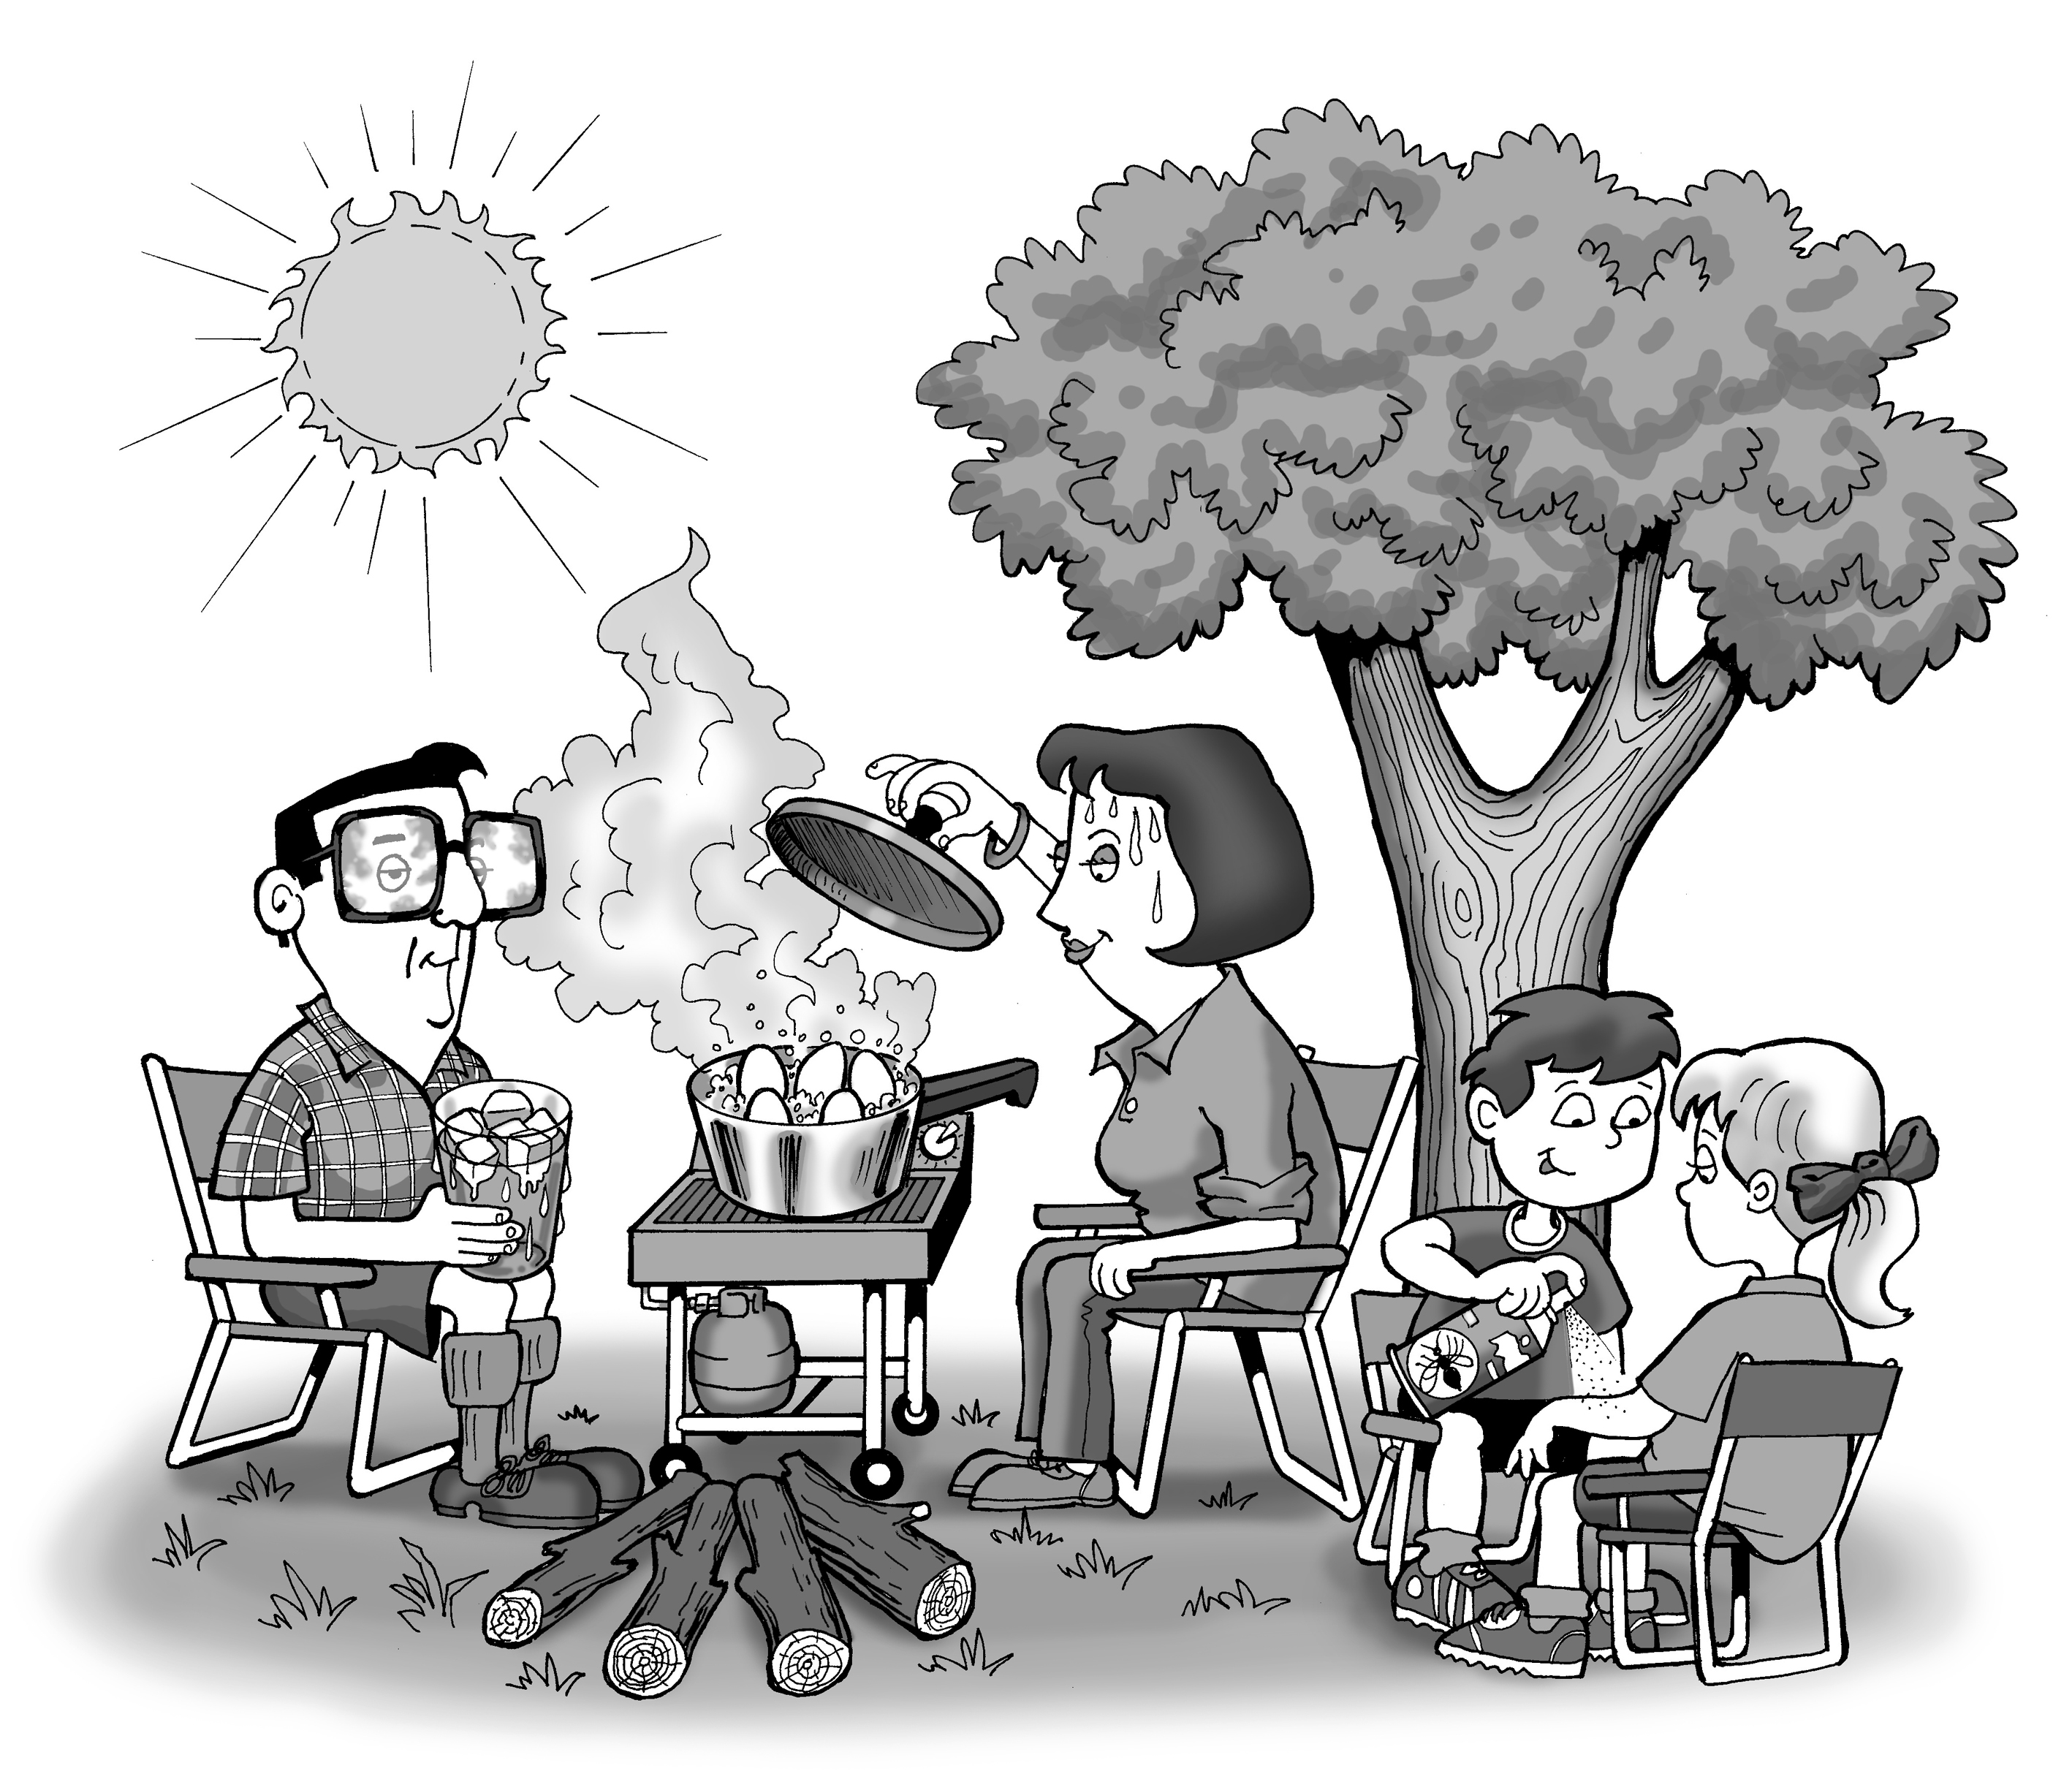
Answers
Even while relaxing on holiday, you can find exothermic and endothermic processes going on all around you.
1. For each of the activities shown on the illustration and listed below, state whether the process indicated is exothermic or endothermic, and then explain your choices. (Remember: an exothermic process results in thermal energy being given out to the surroundings, while an endothermic process requires thermal energy which is drawn in from the surroundings.)

(a) The leaves use energy from the sun to make sugars for the tree (photosynthesis).
Endothermic — energy is being absorbed.
(b) Nuclear reactions in the sun warm the Earth during the day.
Exothermic — energy is being released.
(c) Sweat on a person's face evaporates.
Endothermic — energy is being absorbed. Change of state: liquid → gas.
(d) The gas barbecue burns.
Exothermic — energy is being released
(e) The eggs inside the saucepan cook to become hard-boiled.
Endothermic — energy is being absorbed
(f) Glasses fog up from the boiling water.
Exothermic — energy is being released. Change of state: gas → liquid.
(g) Insect repellent is liquid inside the can, partly gaseous as it comes out of the nozzle.
Endothermic — energy is being absorbed. Change of state: liquid → gas.
(h) Ice melts in a drink.
Endothermic — energy is being absorbed. Change of state: solid → liquid.
2. Which of these processes can be classified as chemical reactions? Explain your choices fully.
Chemical reactions are irreversible and involve the formation of a new substance.
(a) Photosynthesis: carbon dioxide + water → glucose + oxygen
(b) This is an example of a nuclear reaction in which the internal structure of the atom changes and different types of atoms are formed.
(d) Combustion of methane: methane + oxygen → carbon dioxide + water
(e) The proteins in the egg change (denature and coagulate). This is irreversible.

